Our mission is to find a cure for neuroblastoma through funding leading research projects which deliver new, effective and kinder treatments for children.
Thank you for ordering our Christmas cards and helping us give children life and their families hope.

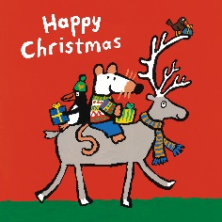
Tracy Beaker’s Christmas Maisy’s Christmas

£2.00 £2.00
Pack of 8 cards Pack of 8 cards
Message inside Message inside
'Seasons Greetings' 'Seasons Greetings'

The Gruffalo’s Christmas Merry Christmas Rudolph
£2.00 £1.50
Pack of 8 cards Pack of 10 cards
Message inside Message inside 'Seasons Greetings' 'Seasons Greetings'
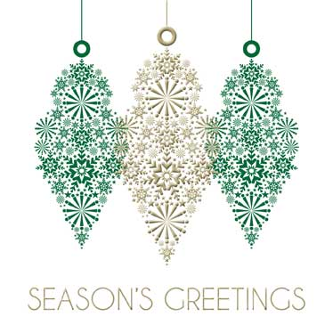
Bright Sparkle Trio of Baubles
£3.00 £3.00 Pack of 10 cards Pack of 10 cards
Message inside ‘Seasons Message inside Greetings’ 'Seasons Greetings'

NEW Out on the Ice
£3.50
Pack of 10 cards
Message inside ‘Seasons
Greetings’

www.neuroblastoma.org.uk
To order cards and support the charity, please make cheques payable to Neuroblastoma UK
and send, along with this form, to:
Christmas Card Organiser, NBUK, 3 Park Farm Road, Kingston, Surrey KT2 5TQ

Design | No. of packs | Price per pack | Total
Tracy Beaker’s Christmas | £2.00
Maisy’s Christmas | £2.00
The Gruffalo’s Christmas | £2.00
Merry Christmas Rudolph | £1.50
Bright Sparkle | £3.00
Trio of Baubles | £3.00
NEW Out on the Ice | £3.50
TOTAL COST OF CARDS
POSTAGE & PACKING |  |  | £3.95
Donation, with thanks If you are a UK tax payer, please consider completing the Gift Aid declaration below
TOTAL

YOUR NAME
ADDRESS
CONTACT EMAIL/TELEPHONE NUMBER IN CASE OF PROBLEMS

Gift Aid Declaration to Neuroblastoma UK
Please treat all donations I have made since 6 April 2000 and* all donations I make hereafter to Neuroblastoma UK as Gift Aid donations and reclaim tax on them. I note the tax position and will let NBUK know if my future giving is not covered by the tax I pay. As a Gift Aid donor you need to be paying UK income tax or capital gains tax at least equal to the amount of tax reclaimed on your donations in each tax year (currently 25p for every £1 you give). Remember to let NBUK know if your tax position changes.
Print Name........................................................ Signature...........................................................
Date..................................................................... *please delete if not appropriate
www.neuroblastoma.org.uk

