FOR NBUK USE ONLY

Date received

Acknowledged

Reference

Final decision

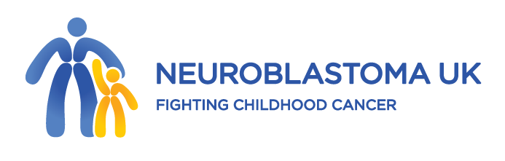

www.neuroblastoma.org.uk Registered Charity No 326385

SMALL GRANT APPLICATION FORM 2024

This form should be used for research or related activities costing less than £5,000. Applicants do not need to be in receipt of current funding from Neuroblastoma UK but must be in a post that is tenured for the period of this grant. The activity described must bring added value to current basic or applied research projects that aim to benefit neuroblastoma patients. Exploring synergies between separate research efforts is encouraged. Applications may be submitted at any time to grants@neuroblastoma.org.uk and will be considered at the next available Trustees’ meeting. Applicants should allow up to 4 months before a decision is made.

- Applicants
Please note that Neuroblastoma UK will consider Applicant 1 as the lead applicant for the purpose of all communication related to the proposal

 | Applicant 1 | Applicant 2 | Applicant 3
Surname
First name
Title
Post held
Date this post expires
Department or Institution with address and postcode

Email address
Telephone

- Title of application or activity

- Total amount requested (£)

- Description of activity
In no more than 500 words, please describe the aims of the activity, exactly what you propose to do and the expected outcomes.

- Please state how this activity will benefit neuroblastoma patients
In no more than 500 words, please outline how the proposed activity will benefit neuroblastoma patients in the short and/or long term.

6. Costs requested
In the table provided, please summarise and justify the costs requested, including the start and end dates for each expenditure. Add additional rows to the table if necessary. Standard or economy class travel must be used. For small meetings, please justify why video or telephone-conferencing cannot be used. Please note that payment will normally be made on receipt of quarterly invoices.

Nature of cost (e.g. travel, consumables, fees) with full justification | Start date | End date | Total cost requested
Full duration
Total cost

7.Please briefly describe the contingencies you have in place if you are unable to work in your Laboratory due to a “Delaying Circumstance” ie. National lockdown due to COVID19 – what processes can you put in place to protect in vivo and/or in vitro work, if applicable?

8.Name, address, telephone and email address of the Officer who should be contacted regarding the administration of the grant.

9..Declaration by the applicants
Each applicant should sign the following declaration:
I confirm that I have approval of the Head of Department and the Institution/Authority administering the funds requested in this application. I further confirm that I will use the funds requested as described in this proposal and provide Neuroblastoma UK with a report on the activity within 2 weeks of the end date.

Name | Signature | Date

APPENDIX 1. Curriculum Vitae of the Applicants

- Name

- Date of birth

- Degrees (subject, class, university and date)

- Current position

- Previous posts (with dates)

